Homework 4

Due: 11:59 PM on Tuesday, March 23, 2021.

Please answer in your own words. Show your work.

1. (10 points) Consider a datagram network using 32-bit host addresses. Suppose a router has four links, numbered 0 through 3, and packets are to be forwarded to the link interfaces as follows:

Destination Address Range Link Interface

11100000 00000000 00000000 00000000

through 0

11100000 00111111 11111111 11111111

-------------------------------------------------------------------------------------------------------

11100000 01000000 00000000 00000000

through 1

11100000 01000000 11111111 11111111

-------------------------------------------------------------------------------------------------------

11100000 01000001 00000000 00000000

through 2

11100001 01111111 11111111 11111111

-------------------------------------------------------------------------------------------------------

otherwise 3

-------------------------------------------------------------------------------------------------------

* 1. Provide a forwarding table that has five entries, uses longest prefix matching, and forwards packets to the correct link interfaces.

Answer:

With this method router matches the prefix of the packet destination address with the entries in the table. If there is match the router forwards the packet to the link associate to that link interface.

After analyzing the above range the appropriate table would have following entries

Option I

|  |  |
| --- | --- |
| **Predix** | **Link Interface** |
| 11100000 00****** | 0 |
| 11100000 01000000 | 1 |
| 1110000* ******** | 2 |
| 11100001 0******* | 2 |
| Otherwise | 3 |

Option II

|  |  |
| --- | --- |
| **Predix** | **Link Interface** |
| 11100000 00****** | 0 |
| 11100000 01000000 | 1 |
| 1110000* ******** | 2 |
| 11100001 1 | 3 |
| Otherwise | 3 |

* 1. Describe how your forwarding table determines the appropriate link interface for datagrams with the following destination addresses:

200.145.81.85

225.64.195.60

225.128.17.119

Be sure to identify the link interface for each address.

Answer:

For finding the link interface we will go with Option II table.

First convert the value into binary:

200.145.81.85

Binary conv: 11001000.10010001.1010001.01010101

So if we check the prefix it is not matching any value in the forwarding table so it will fall in last case that is otherwise so it will go to link **interface 3.**

---------------------------------------------------------------------------------------------------------------------------

Now Lets do It for second destination address:

225.64.195.60

Binary conv: 11100001.01000000.11000011.00111100

So if we check in forwarding table to match the prefix and the longest prefix matched is

the entry at row three which means router will route it to link **interface 2**

---------------------------------------------------------------------------------------------------------------------------

Now for the last destination address:

225.128.17.119

Binary value: 11100001.10000000.00010001.01110111

So if we check in forwarding table to match the prefix and the longest prefix match is

the entry at row four which means router will route it to link **interface 3**

1. (20 points) Consider the following questions on IP addressing using CIDR:
   1. Suppose that you request IP addresses for 1,200 hosts and are allocated a subblock from the 223.1.* address range as follows:

223.1.0.*

223.1.1.*

223.1.2.*

223.1.3.*

223.1.4.*

Using address and prefix format (e.g., 128.2/16), what is the smallest set of network addresses that can describe this network under CIDR?

Answer:

The smallest network address that can support 1200 host is :

223.1.0/22 and 223.1.4/24

* 1. Now suppose that another (i.e., remote) router has produced the following forwarding table:

Destination Next Hop

223.1/16 1.2.3.4

223.1.0/23 1.2.3.5

223.1.4/24 1.2.3.6

223.1.1/24 1.2.3.7

What is the next hop that the router should use for a packet destined for 223.1.0.1? Note that this question is not related to the answer for part (a) above.

Answer:

If we identify the longest prefix in above forwarding table, the next hop for 223.1.0.1 is **1.2.3.5**. As we can see the longest match is 223.1.0/23 in this case.

* 1. Determine the network address and total number of IP addresses in the subnet for the following IPv4 address and CIDR mask: 156.143.10.55/21

Answer:

To determine the network address, we first convert the decimal into binary:

Decimal – 156.143.10.55/21

Binary - 10011100.10001111.00001010.00110111

Subnet host part

So the network address is : 156.143.8.0/21 or 156.143.8.*

To calculate the total number of IP address we know host part is 11(which is suffix, so the number of IP addresses can be calculated as **211 = 2048 – 2 = 2046**

* 1. Suppose that the first IP address in the block is 230.8.16.0 and the last address in the block is 230.8.31.255. Find the number of bits in the subnet portion of the address (i.e., the CIDR). Justify your answer (i.e., describe the process you used to determine the CIDR).

Answer:

To determine the subnet portion of CIDR , we will identify the longest common bits in given two addresses.

Fist IP is 230.8.16.0 – 11100110 00001000 00010000 00000000

Second IP is 230.8.31.255 - 11100110 00001000 00011111 11111111

Common sequence is in box, therefore we can say number of **bits in subnet portion is 20.**

1. (10 points) Consider a subnet with prefix 128.119.40.128/26.
   1. Provide an example of one IP address (using the form xxx.xxx.xxx.xxx) that can be assigned to this network.

Answer:

The subnet part is 26(prefix)

That means host part is 6(suffix)

So the IP address supported is 26 = 64 -2 possible values, so we can choose any IP address between 128.119.40.128 to 128.119.40.191.

Example for one IP address is: **128.119.40.132**

**10000000 01110111 00100111 10000100**

Subnet prefix host

* 1. Suppose an ISP owns the block of addresses of the form 128.119.40.64/26. Suppose the ISP then wants to create four subnets from this block, with each block having the same number of IP addresses. What are the prefixes (using the form a.b.c.d/x) for the four subnets?

Answer:

26+2 = 28

32- 28 = 4

24 = 16

So 16 is block size for each block

Four subnets block can be :

128.119.40.64/28

128.119.40.80/28

128.118.40.96/28

128.118.40.112/28

1. (20 points) Consider that your ISP assigned the IP address 168.27.3.4 to your home router running NAT, while your computer’s IP address is 192.168.5.5. Suppose you want to download a web page from the server 212.34.2.3. Fill in the NAT table entry for the connection as well as the source and destination IP address and port in the diagram below.

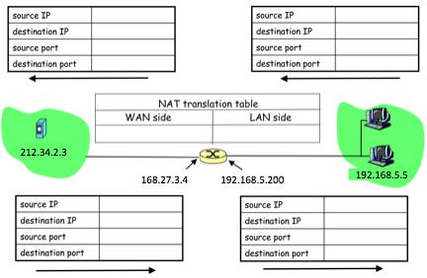

Answer:

So, let’s consider the port for the web page(destination) is 80:

The host will assign an arbitrary port let say 3345 and sends datagram to WAN side.

“The NAT router receives the datagram, generates a new source port number 5001 for the datagram, replaces the source IP address with its WAN-side IP address 168.27.3.4, and replaces the original source port number 3345 with the new source port number 5001.”[1]

|  |  |
| --- | --- |
| NAT translation table | |
| WAN Side | LAN side |
| 168.27.3.4, 5001 | 192.168.5.5, 3345 |

Now for the other four table:

Step 1: upper right table

|  |  |
| --- | --- |
| Source IP | 192.168.5.5 |
| Destination IP | 212.34.2.3 |
| Source Port | 3345 |
| Destination Port | 80 |

Step 2: upper left table

|  |  |
| --- | --- |
| Source IP | 168.27.3.4 |
| Destination IP | 212.34.2.3 |
| Source Port | 5001 |
| Destination Port | 80 |

Step 3: lower left table

|  |  |
| --- | --- |
| Source IP | 212.34.2.3 |
| Destination IP | 168.27.3.4 |
| Source Port | 80 |
| Destination Port | 5001 |

Step 4: lower right table

|  |  |
| --- | --- |
| Source IP | 168.27.3.4 |
| Destination IP | 192.168.5.5 |
| Source Port | 5001 |
| Destination Port | 3345 |

1. (20 points) Consider the scenario where a DHCP client arrives and requests an IP address from the DHCP server:

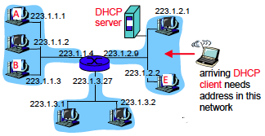

In the simplest case, four DHCP messages will be exchanged according to the figure below. Identify and fill in the missing fields for each DHCP message. You may assume that the subnet to which the DHCP client arrives is a /24 network and that all addresses below 223.1.2.10 are occupied. You may select a reasonable transaction ID and suitable IP address (based on requirements just mentioned).

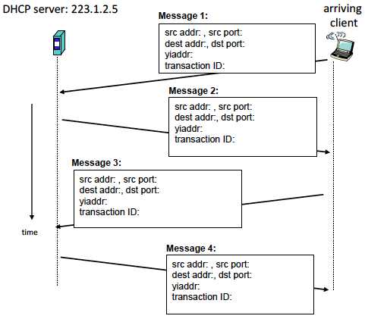

Answer:

Message1: In this process arriving host is discovering DHCP server:

src addr: 0.0.0.0, src port: 68

dest addr : 255.255.255.255, dst port: 67

yiaddr: 0.0.0.0

transaction ID: 654

Message 2: A DHCP server receiving a DHCP discover message responds to the client with a DHCP offer message.[1]

src addr: 223.1.2.5, src port: 67

dest addr : 255.255.255.255, dst port: 68

yiaddr: 223.1.2.11

transaction ID: 654

Message3: The new arriving host will select among one or more server offers and respond to its selected offer.

src addr: 0.0.0.0, src port: 68

dest addr : 255.255.255.255, dst port: 67

yiaddr: 223.1.2.11

transaction ID: 655

Message 4: Lastly DHCP sends acknowledgement.

src addr: 223.1.2.5, src port: 67

dest addr : 255.255.255.255, dst port: 68

yiaddr: 223.1.2.11

transaction ID: 655

1. (10 points) Consider the SDN OpenFlow network shown below:

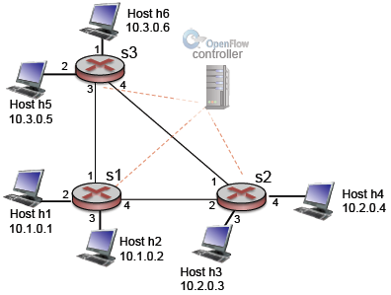

Suppose that the desired forwarding behavior for datagrams arriving from host h3 or h4 at s2 is as follows:

* Any datagrams arriving from host h3 and destined for h1, h2, h5, or h6 should be forwarded in a clockwise direction in the network.
* Any datagrams arriving from host h4 and destined for h1, h2, h5, or h6 should be forwarded in a counter clockwise direction in the network.

Specify the flow table entries in s2 that implement this forwarding behavior.

Answer:

As we know for h3 we need to consider the clockwise direction. So, for h4 and h6 it bypasses the direct link 1 between s2 and s3. Similarly, for host h4 it bypasses the direct link 2 between s2 and s1 for h1 and h2 destination host since we need anticlockwise direction in network.

|  |  |
| --- | --- |
| Match | Action |
| Ingress port = 3; IP src= 10.2.0.3, IP dest = 10.1.*. * | Forward (2) |
| Ingress port = 3; IP src= 10.2.0.3, IP dest = 10.3.*. * | Forward (2) |
| Ingress port = 4; IP src= 10.2.0.4, IP dest = 10.1.*. * | Forward (1) |
| Ingress port = 4; IP src= 10.2.0.4, IP dest = 10.3.*. * | Forward (1) |

**s2 Flow Table**

1. (10 points) IP Fragmentation
   1. Suppose the Maximum Transmission Unit (MTU) over a link is 420 bytes. If you send a 600 byte IPv4 packet (with 20 bytes header) over this link, how many packets will need to be sent? For each outgoing packet, identify the value of the datagram length, flags, and fragmentation offset fields.

Answer:

Maximum Transmission Unit (MTU) over link is– 420byte.

Data we need to send = 600 bytes

No of packets required to send 600bytes data: 2

The required number of fragments = $\left[\frac{Datagram-IP header}{MTU-IP header}\right]$

= $\frac{600-20}{420-20}$ = 1.45 $≈2.0$

|  |  |  |  |
| --- | --- | --- | --- |
| Packet | Datagram length | Flag | Fragmentation offset |
| 1 | 420 | 1 | 0 |
| 2 | 200 | 0 | 50 |

Second packet fragmentation offset calculation: 400/8 = 50

* 1. When the destination router receives an IP fragment, it keeps the fragment in a buffer until the other fragments are received. How does the router know how much buffer space to allocate for the reassembly of the IP datagram? Or does it know? Justify (or provide some details to) your answer.

Answer:

No, the router does not know how much buffer space to reassemble the IP datagram. The destination router keeps the fragments in buffer until all the fragments are received, since it is unaware of the number of fragments so, it will choose largest available buffer space while receiving fragments of an IP datagram.

The packets do not contain count of fragments which router going to sent for a single datagram. The two different datagrams can be distinguishing by Incremental Identification number, but the router does not have any mechanism to control the number of fragments for a single datagram.

References:

[1]: Textbook: Computer Networking: A Top-Down Approach featuring Internet 7th edition, Kurose and Ross, Addison Wesley,